FX Pick of the Day

15 November, 2011



Currency | Short Term  Technical Support | Short term  Technical Resistance | Buy/Sell Suggestion | Suggested Target Level
EUR/USD | 1.3500 | 1.4000 | Short at Spot | 1.3450 (Stop loss at 1.3750)
EUR/AUD | 1.3240 | 1.3455 | Short at Spot | 1.3150 (Stop loss at 1.3440)

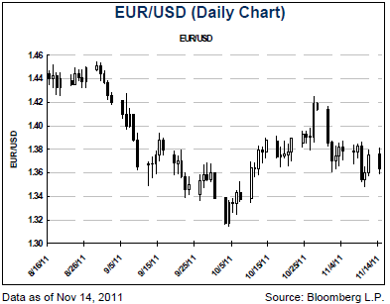

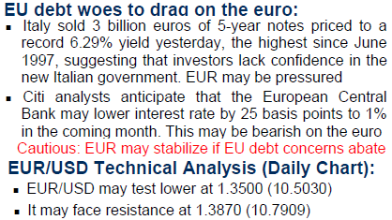
The brackets are the exchange rates in terms of Hong Kong dollar, with HKD $7.78 exchange rate for reference, and 1,000 yen per unit for JPY/HKD.
For any enquiries, please call (852) 2860-0333.
This document is based on information provided by Citigroup Investment Research, Citigroup Global Markets, Citigroup Global Wealth Management and Citigroup Alternative Investments. It is provided for your information only. It is not intended as an offer or solicitation for the purchase or sale of any investment. Information in this document has been prepared without taking account of the
objectives, financial situation or needs of any particular investor. Accordingly, investors should, before acting on the information, consider its appropriateness, having regard to their objectives,
financial situation and needs. Any decision to purchase securities mentioned herein should be made based on a review of your particular circumstances with your financial adviser. Investments referred to in this document are not recommendations of Citibank (Hong Kong) Limited (“Citibank”) or its affiliates. Although information has been obtained from and is based upon sources that Citibank believes to be reliable, Citi analysts do not guarantee its accuracy and it may be incomplete and condensed.

All opinions, projections and estimates constitute the judgment of the author as of the date of publication and are subject to change without notice. Prices and availability of financial instruments also are subject to change without notice. Past performance is no guarantee of future results. The document is not to be construed as a solicitation or recommendation of investment advice. Subject to the nature and contents of the document, the investments described herein are subject to fluctuations in price and/or value and investors may get back less than originally invested. Certain high- volatility investments can be subject to sudden and large falls in value that could equal the amount invested. Certain investments contained in the document may have tax implications for private customers whereby levels and basis of taxation may be subject to change. Citibank does not provide tax advice and investors should seek advice from a tax adviser. Investment products: (i) are not insured by the Federal Deposit Insurance Corporation; (ii) are not deposits or other obligations of any insured depository institution (including Citibank); and (iii) are subject to investment risks, including the possible loss of the principal amount invested.

